**Binomial Theorem**



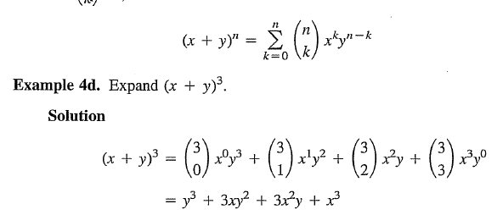

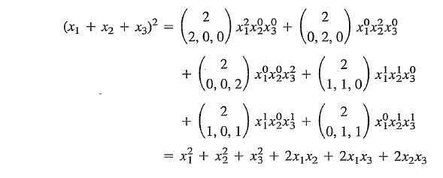

Ex]A system has six components. Each component has a failure probability, independent of any other component. What is the probability that the operation is successful?

* Write your answer in terms of.













If operation is successful, then











As you can see from the system, the probability that the operation is successful is



**Discrete Random Variables**

***Based on Wikipedia***

*A* ***random variable*** *is a mathematical function that maps outcomes of random experiments to numbers. For example, a random variable can be used to describe the process of rolling a fair die and the possible outcomes { 1, 2, 3, 4, 5, 6 }.*

**Random variable**

A Random variable consists of an experiment with a probability measure defined on a sample space and a function that assigns a real number to each outcome in sample space of the experiment.

**Range of *X*:** Set of possible values of Random Variable *X*



Notation:  is the range of random variable X



# Discrete random variable

X is a discrete random variable if the range of *X* is a countable set.

 : set of possible values can be listed.

**Finite random variable**

X is a finite random variable if the range is a finite set.



* In general, the main reason for introducing the concept of a random variable is **to compute average**.
* In the mathematics of probability, averages are called
  + expected values
  + expectations
  + Mean
  + 1st moment
  + Average

**Probability Mass Function** (**PMF**) – Probability model

When we have a discrete random variable *X*, we express the probability model as a **probability mass function**.

### Probability model PMF is defined as

For any values of , the function  is the probability of the event 

Ex 2.5] Suppose we observe three calls at a telephone switch where voice calls (v) and data calls (d) are equally likely. Let X denotes the # of voice calls, Y the # of data calls, and let. The sample space of the experiment and the corresponding values of the random variables, X, Y, and R are

|  |  |  |  |  |  |  |  |  |
| --- | --- | --- | --- | --- | --- | --- | --- | --- |
| Outcomes | ddd  1/8 | ddv  1/8 | dvd  1/8 | dvv  1/8 | vdd  1/8 | vdv  1/8 | vvd  1/8 | vvv  1/8 |
| X | 0 | 1 | 1 | 2 | 1 | 2 | 2 | 3 |
| Y | 3 | 2 | 2 | 1 | 2 | 1 | 1 | 0 |
| R | 0 | 2 | 2 | 2 | 2 | 2 | 2 | 0 |

From the chart above, find PMF of R.









**Theorem**

For a discrete random variable *X* with PMF  and range 

1. For any , 
2. 
3. For any events , the probability that *X* is in the set B is



Quiz 2.2]

The random variable *N* has PMF



Find

1) The value of the constant *c*?



2)  ?



3)  ?



4)  ?

0

**2.3 Families of Discrete Random Variables(1:6) vs. Cont. RV (7:11)**



##### **Bernoulli (p) random variable**

*X* is a Bernoulli (p) random variable if the PMF of *X* has the form



where the parameter *p* is in the range 

##### **Geometric Random Variable**



where the parameter *p* is in the range 

Ex] if *p* = 0.2 then





##### **Binomial Random Variable**



where the parameter *p* is in the range  and *n* is an integer such that 

##### **Pascal Random Variable**



where the parameter *p* is in the range  and K is an integer such that .

##### **Discrete Uniform (*k,l*) Random Variable**

X is a discrete uniform (*k,l*) random variable if the PMF of X has the form



where the parameter *k* and *l* are integers such that *k<l*

Ex)



##### **Poisson Random Variable**

### X is a Poisson () random variable if the PMF of X has the form



where the parameter  is in the range >0

Ex) *x*=0:15 and =0.5

